## [Supervised Machine Learning: Regression and Classification](https://www.coursera.org/learn/machine-learning/home/week/1)

**Week 1 - Introduction to Machine Learning**

This week they talked about supervised and unsupervised learning, regression models and gradient descent.

Below you can see some intuition for the **cost function**, different parameters of w resulting in different costs.

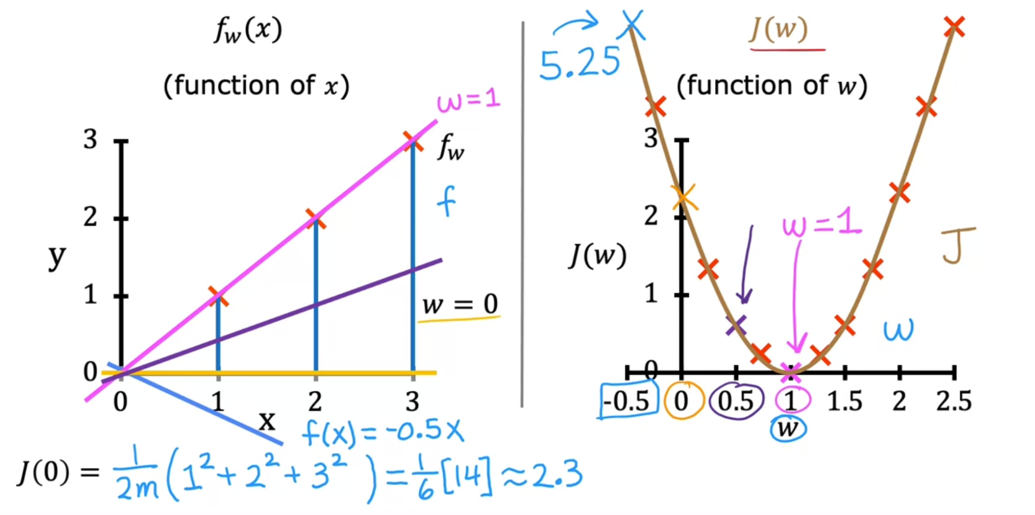

Now you can see the implementation of the gradient descent algorithm.

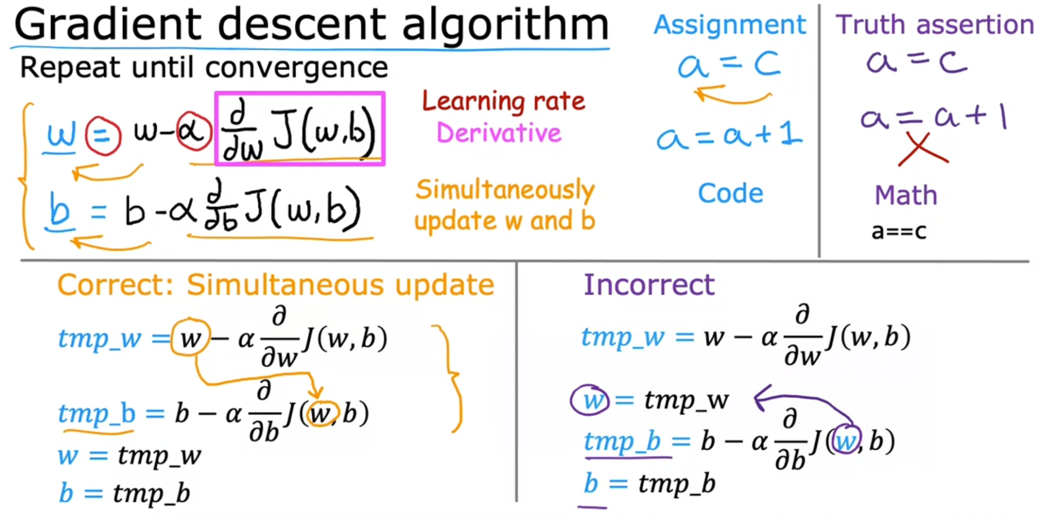

Then you can see the intuition for gradient descent below.

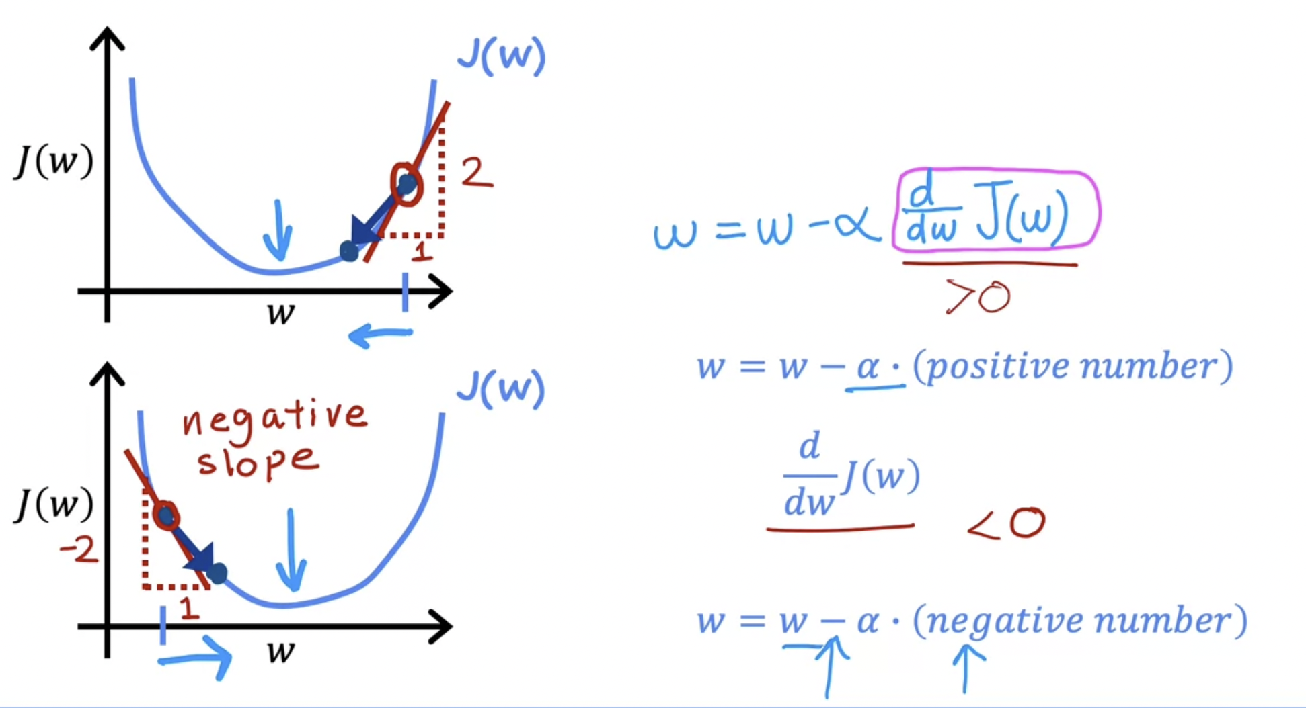

**Week 2 - Regression with multiple input variables**

This week they talked about multiple linear regression and gradient descent in practice.

One example of a model with multiple variables is shown below.

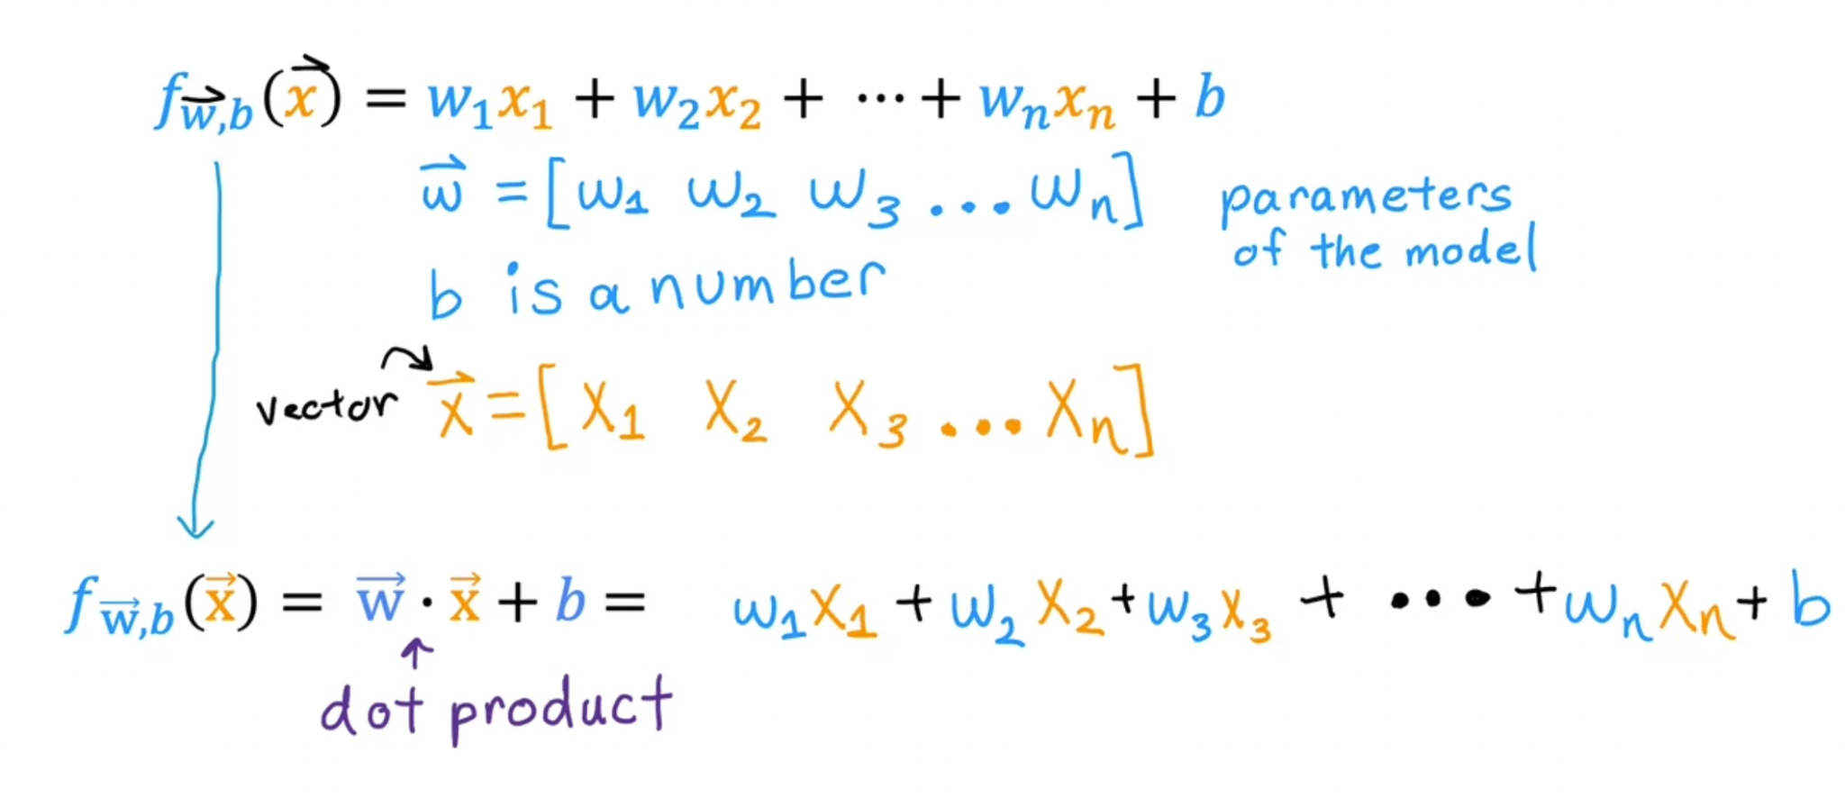

The gradient descent algorithm for multiple variables look like this:

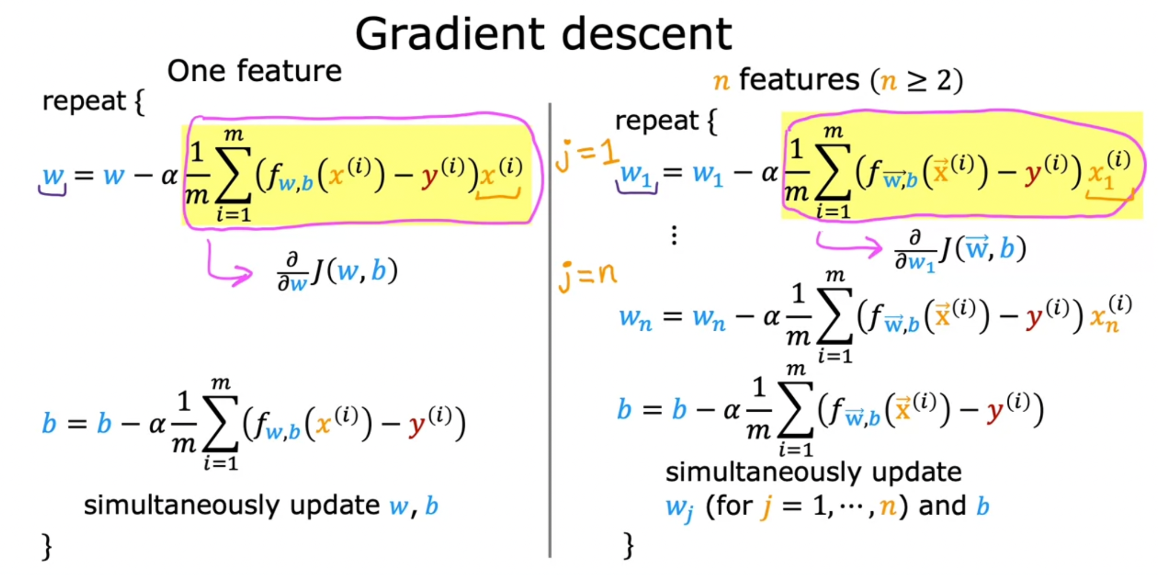

Then, for checking the convergence of the algorithm you should look at the decrease of the cost per iteration.

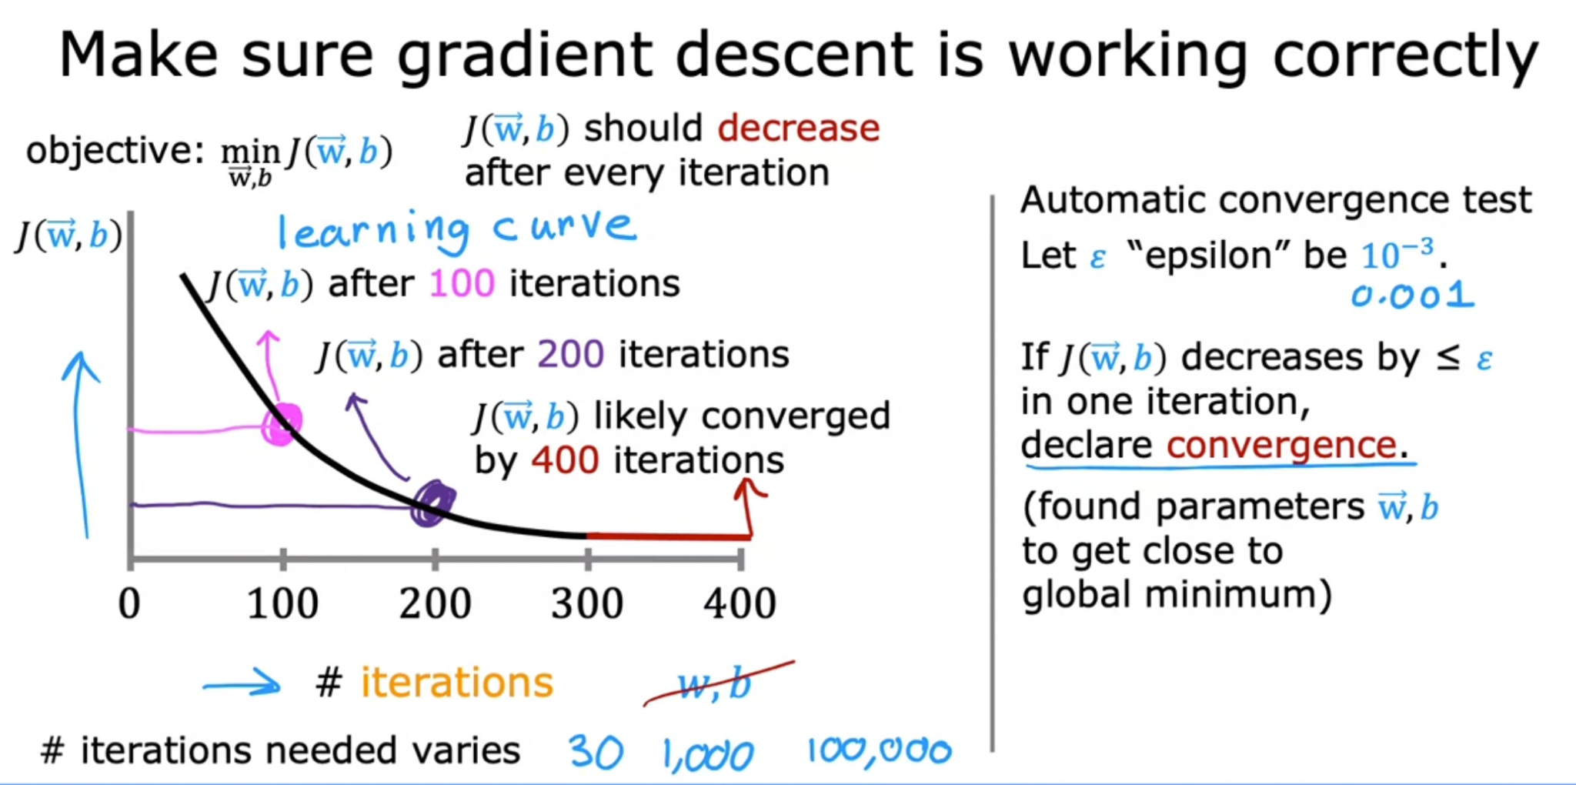

**Week 3 - Classification**

This week they talked about classification with logistic regression, cost function, and gradient descent, and also touched base on the problem of overfitting.

The mai difference between linear and logistic regression is the link function.

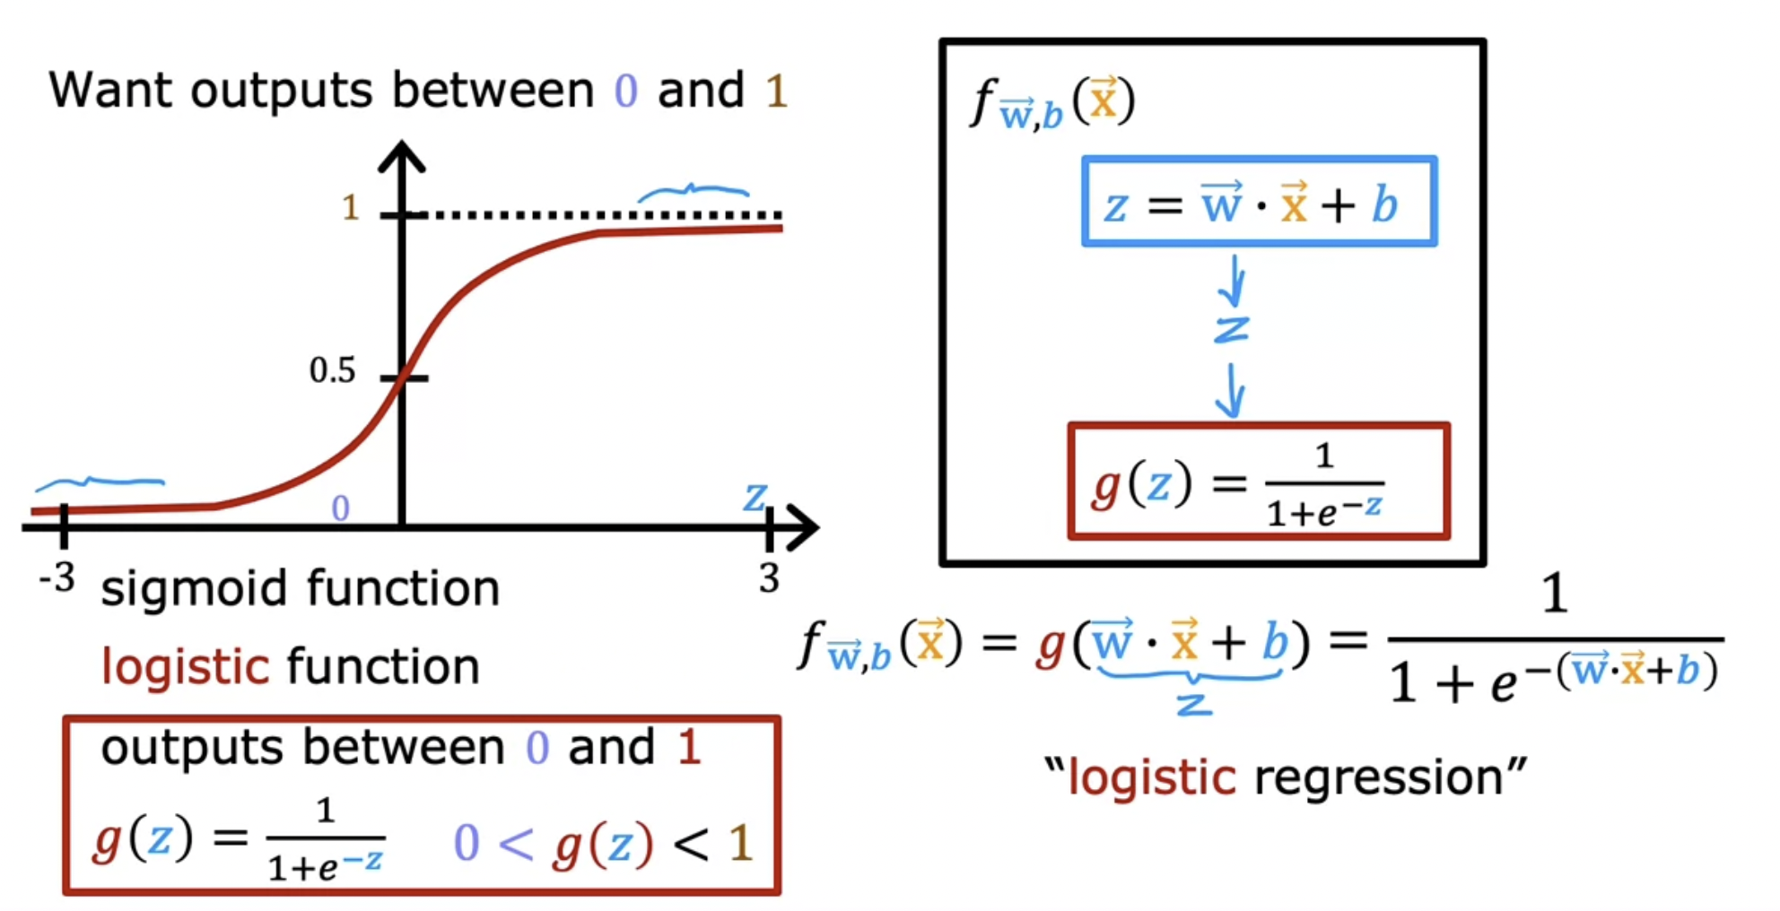

Below you can see the cost function for the logistic regression.

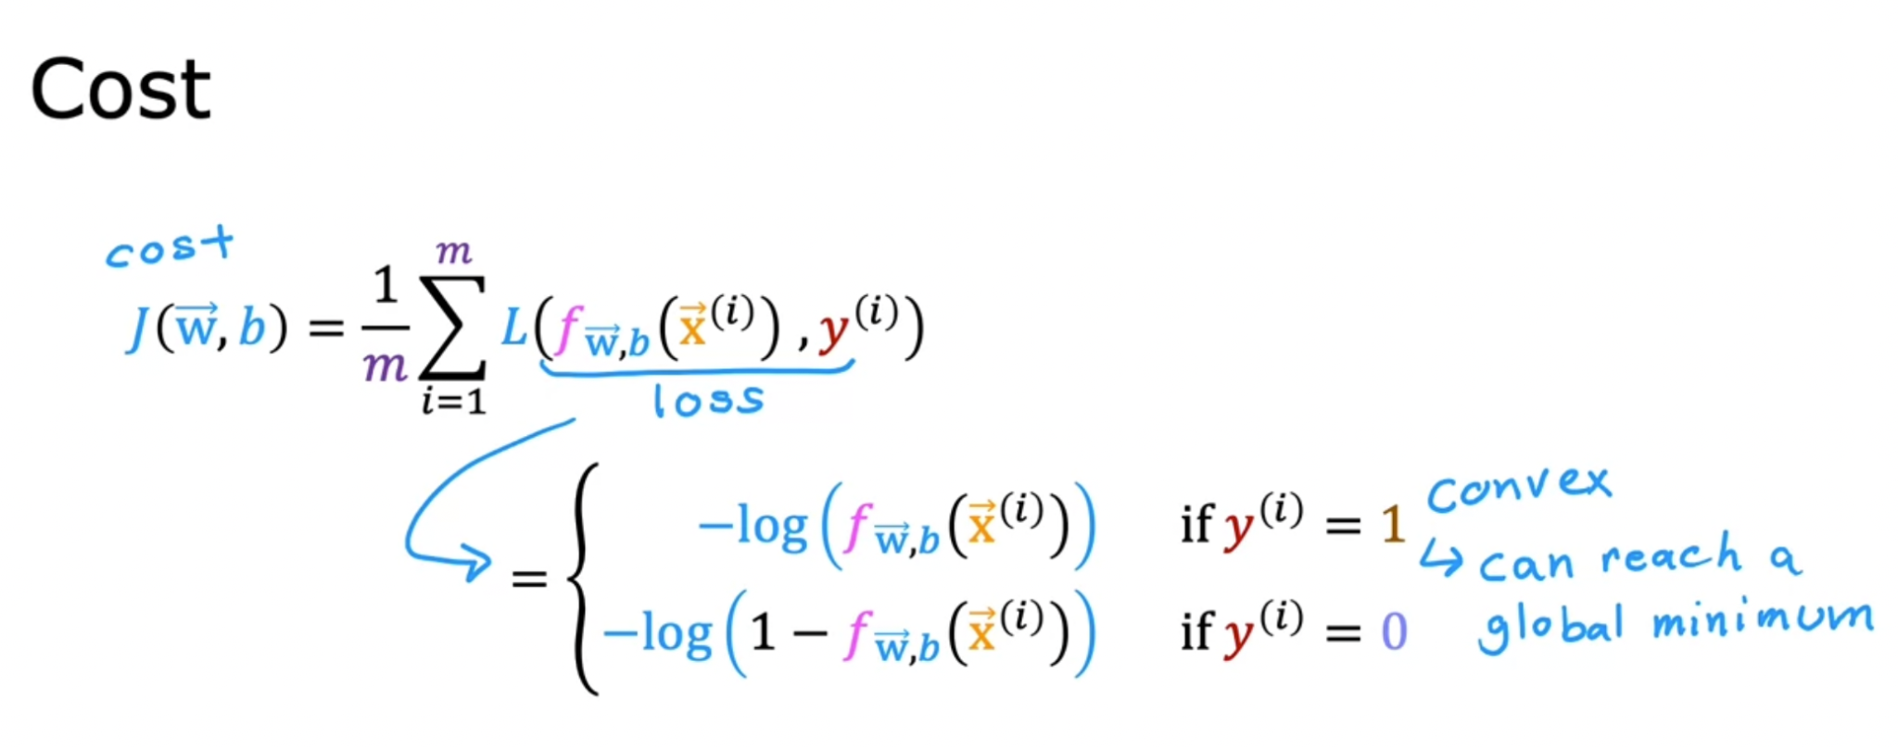

The gradient descent for logistic regression is presented below.

